CHAROTAR UNIVERSITY OF SCIENCE & TECHNOLOGY
Chandubhai S Patel Institute of Technology
V.T. Patel Department of Electronics & Communication

Report Summary

Advancing Semiconductor Design with Test-Driven Techniques

No. of Participants: - 15
Organized by: VLSI Club, EC Department
In Collaboration with: eInfochips – An Arrow Company
Date: January 22-24, 2025
Faculties
15

Resource Persons:
- Chintan Panchal
- Moksh Sancheti
- Saurin
- Kishor
- Kamya Ahuja
- Manali Hinsu

Objective
The Faculty Development Program (FDP) aimed to enhance the understanding of semiconductor testing methodologies, focusing on Design for Testability (DFT), Scan Insertion, Automatic Test Pattern Generation (ATPG), and Memory Built-In Self-Test (MBIST). The sessions provided theoretical insights along with hands-on experience in industry-standard testing techniques.

Program Overview

Day 1: Introduction and Basics of DFT, Scan Insertion
The first day introduced participants to fundamental concepts of DFT and scan insertion. The sessions covered:
- ASIC Flow & DFT Integration: Understanding DFT’s role in ASIC design.
- Overview of DFT: Introduction to faults, defects, and the need for structured testing.
- Scan Insertion Techniques: Structural testing, scan chains, and testability considerations in flip-flop design.
- Advanced Topics in Scan Design: Different types of scan architectures, shift & capture mechanisms, and compression techniques.
The day concluded with an in-depth discussion on the significance of scan insertion in modern semiconductor design.

Day 2: ATPG, MBIST, and Industry Applications
The second day focused on ATPG (Automatic Test Pattern Generation) and MBIST (Memory Built-In Self-Test) techniques:
- ATPG Basics: Fault types (Stuck-At, Transition Delay Faults), testing metrics, and their importance.
- Memory Testing with BIST: BIST architecture, need for memory testing, common fault types, and implementation strategies.
- Industry Applications of DFT: A dedicated session where industry experts shared insights on practical implementations of DFT and real-world challenges.

Day 3: Hands-on Session
The final day was a practical, hands-on session where participants applied the concepts learned over the previous days. Industry professionals guided attendees through real-world testing scenarios using simulation tools.

Outcome
The FDP successfully provided participants with a comprehensive understanding of semiconductor testing methodologies. Attendees gained insights into industry trends and enhanced their ability to integrate DFT techniques into academic research and teaching. The interactive sessions and hands-on training ensured practical exposure, making the program highly impactful.

Conclusion
The program received positive feedback from participants, who appreciated the balance between theoretical concepts and hands-on learning. The collaboration with eInfochips – An Arrow Company provided valuable industry expertise, bridging the gap between academia and real-world semiconductor design challenges.

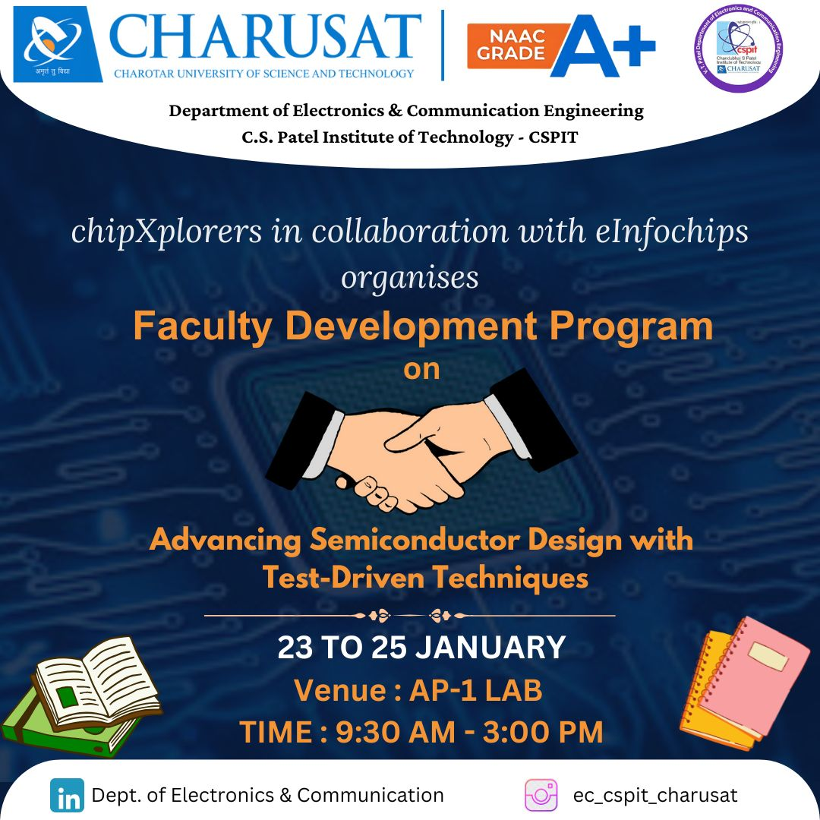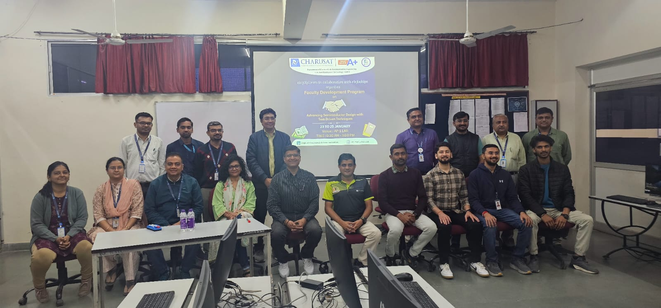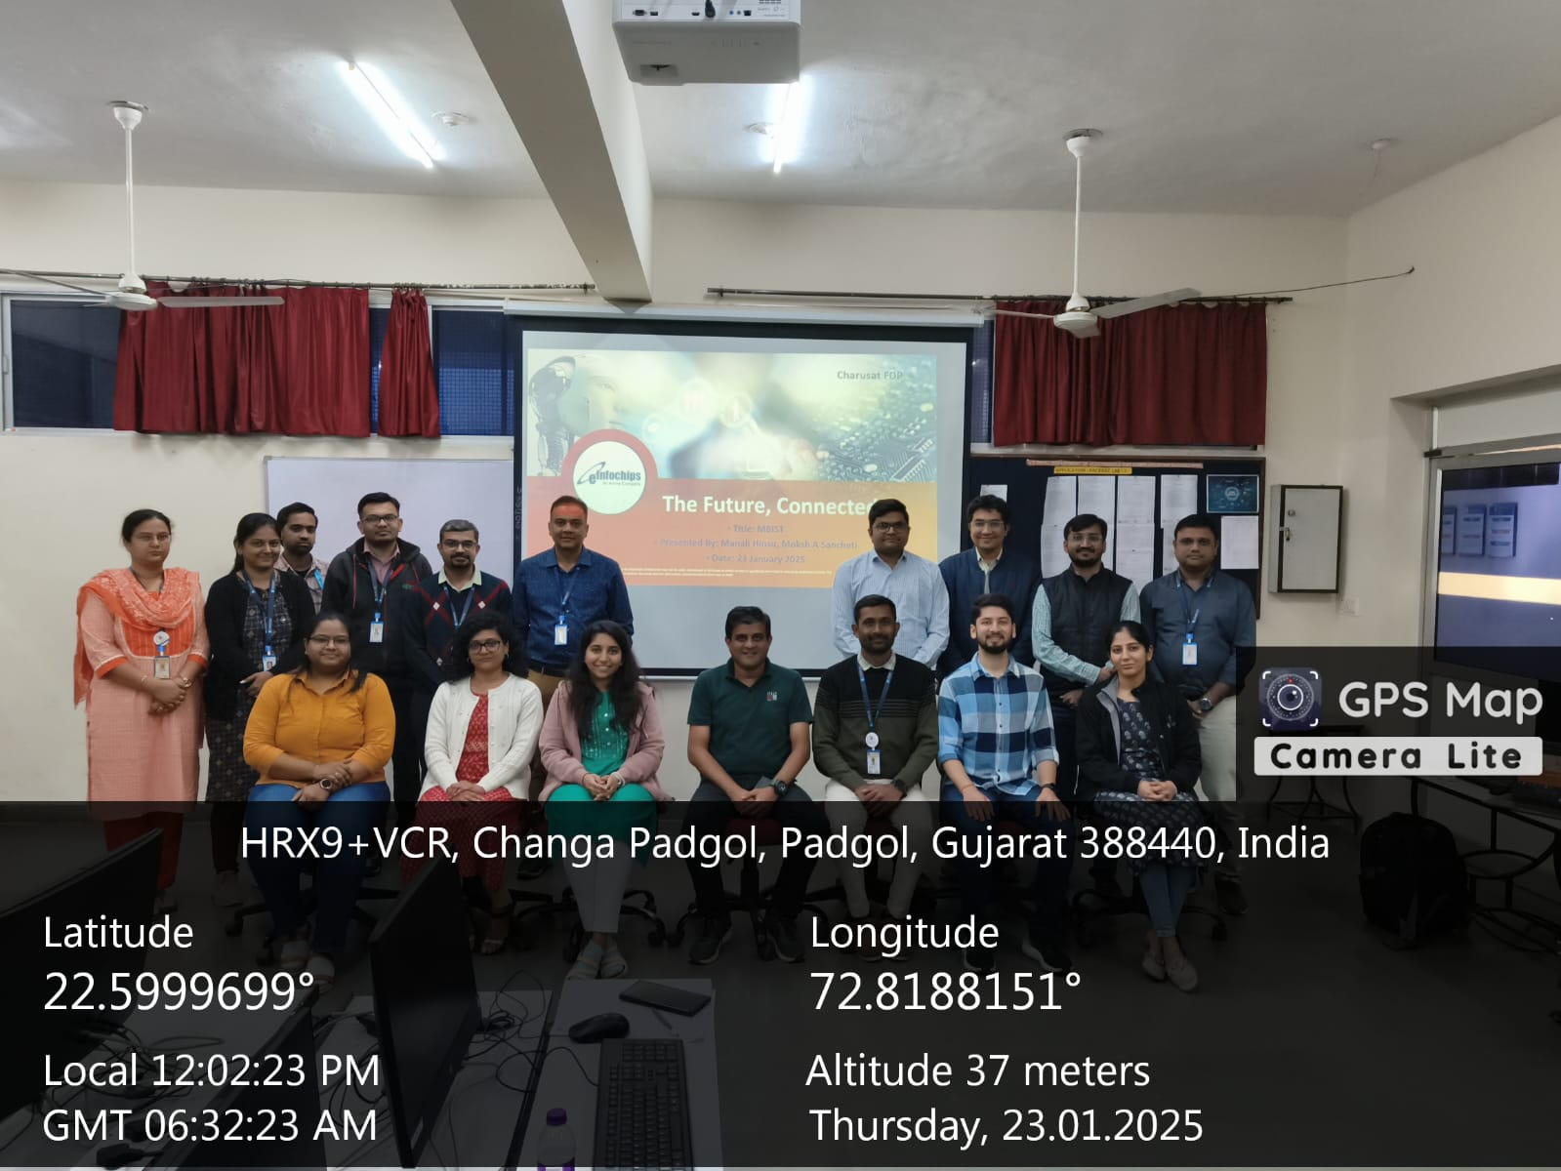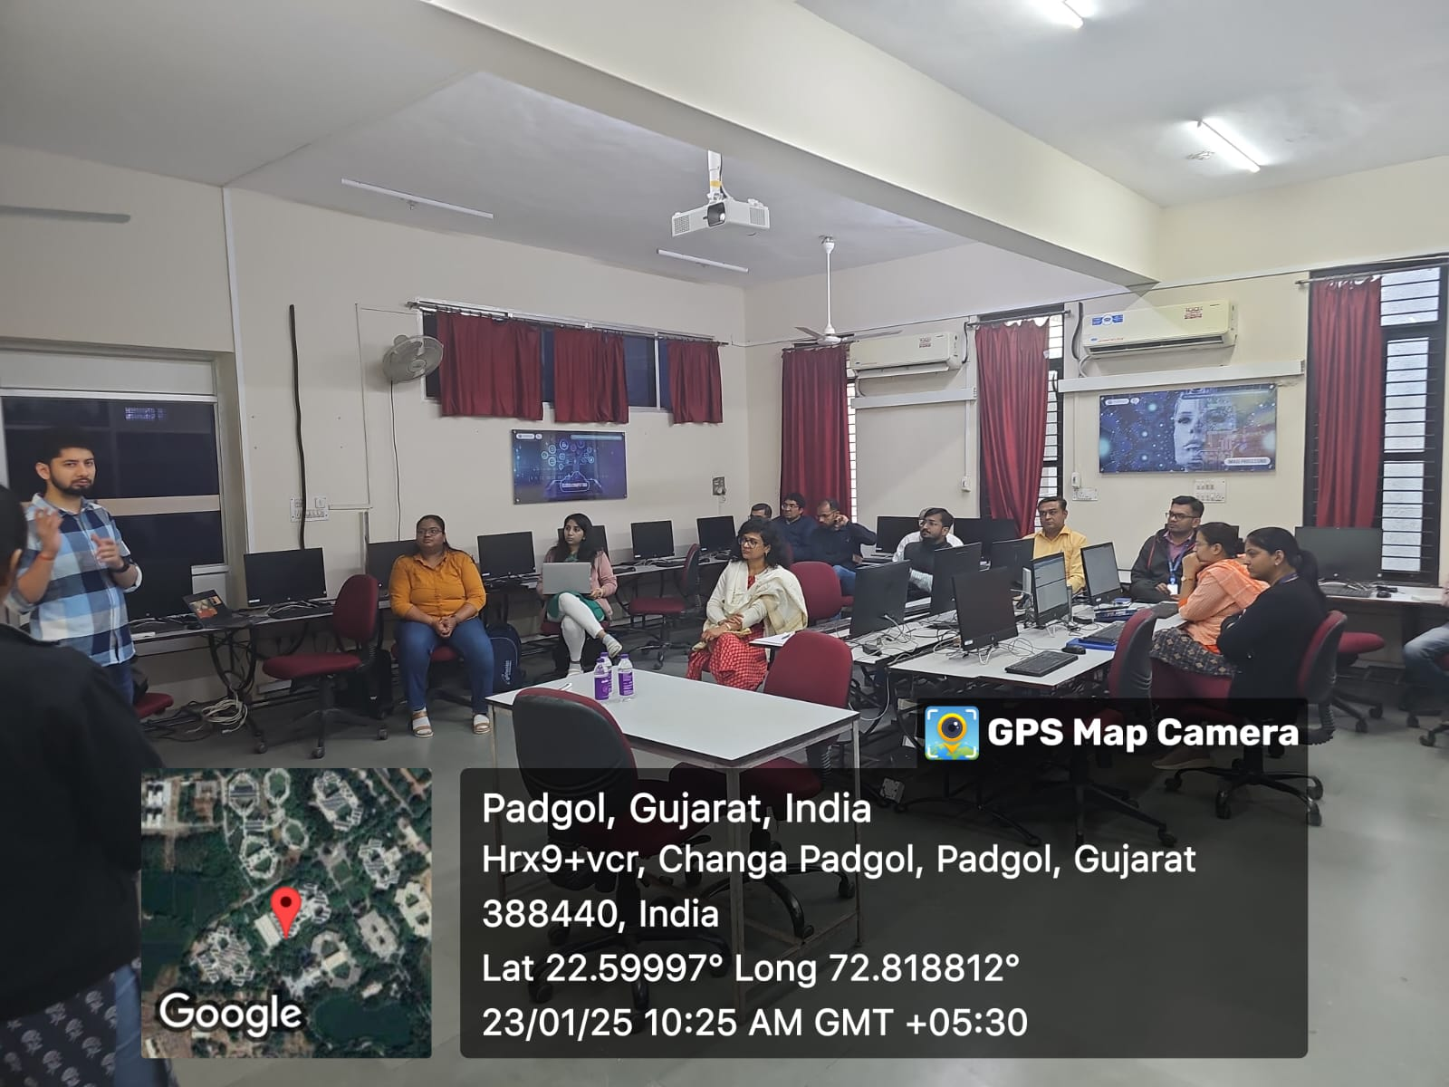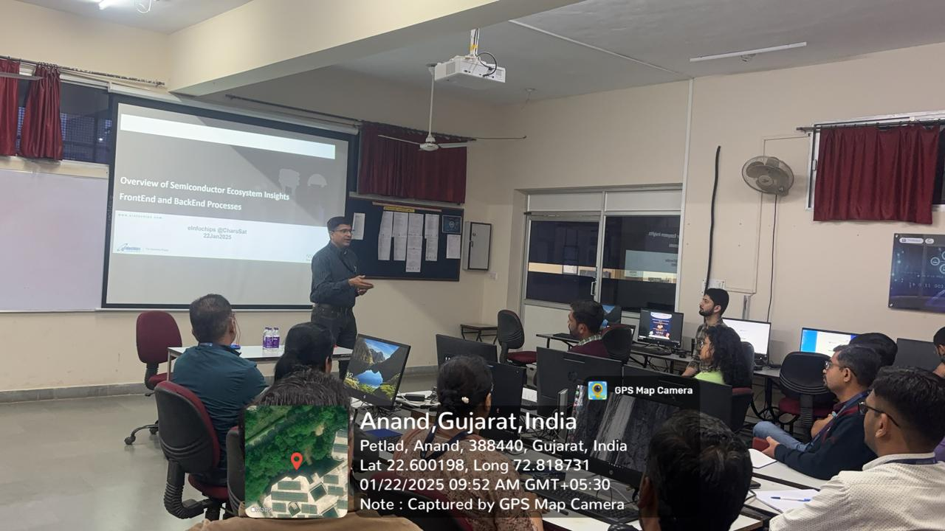

a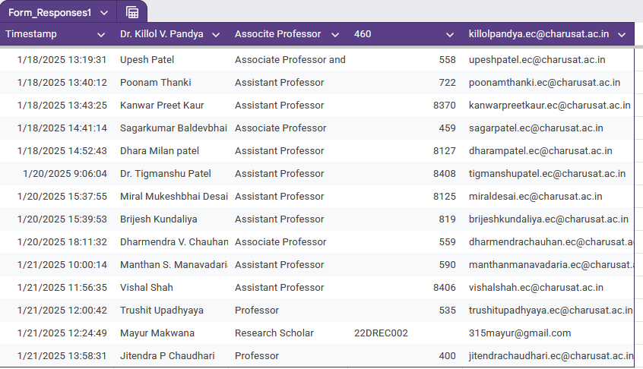

Dr.Arpita Patel
Associate Professor
Ph.D
VLSI,Wireless

